Project Analysis Document
Group 9:
Anton Alexander, Eric Monk, Jay P. Boring, Sallie Kihu
University of Maryland University College

Author Note:
Revision: 6.0

Date: 02/01/2015

Class #: CMSC 495 6380
Revision History

Revision | Date | Name of editor | Description
1 | 01/30/2015 | Jay Boring, Anton Alexander | Original Document
2 | 01/30/15 | Sallie Kihu | Revision
3 | 01/31/15 | Eric Monk | Revision: Project Enhancements/Risk & Mitigation/Minor Edits
4 | 01/31/15 | Anton Alexander | Additional content
5 | 02/01/15 | Jay Boring | Final edits
6 | 02/01/15 | Anton Alexander, Jay Boring | Final additons, final cleanup

Project Analysis:

I) Analysis

Our project is to create an application that keeps track of your loved ones special dates (e.g. anniversaries, birthdays, etc.) and their wish lists.

Its functional requirements are repeated here for convenience:

Requirement # |  | Description
1 | The system shall keep track of individual person names
2 | The system shall keep track of dates
3 | The system shall correlate dates to people’s special events
4 | The system shall keep track of wish lists
5 | The system shall correlate wish lists to individual people
6 | The system shall Provide a GUI for entering in special dates
7 | The system shall Provide a GUI for Displaying information on individual’s special dates
8 | The system shall Provide a GUI for Displaying information on individual’s wish lists
9 | The system shall allow the user to change the background colors
10 | The system shall allow the user to change the font
11 | The system shall allow the user to edit current special dates and lists
12 | The system shall allow the user to set alert on/off to note special date
13 | The system shall allow the user to add a picture/graphic to a specific event
14 | The system shall have a drop down menu of event categories
15 | The system shall have a drop down menu to choose day, time, year of event
16 | The system shall allow a user to add a note to an event
17 | The system shall allow a user to make multiple events
18 | The system shall allow a user to repeat an event
19 | The system Shall not allow duplicate persons
20 | The system shall not automatically delete events

First, we must find the solution to our problem by answering the questions regarding input data, output data and processing function to convert input data into output data. We identify the following:
- Outside system: The user
- Input data: Names, Dates, Wish Lists, Special Event Dates, Font selection, Background selection, Alert on/off, Color selection, Picture or graphic addition to events; These will be provided by the user.
- Output data: Display of Wish lists correlated with people, display of important dates, display of correct font, display of correct background selection, display of picture associated with an event, display alert to an event.
- Data Processing: Maintain a database of information for People's names, special dates, wish lists, create events and store. Do not allow duplication of people.

The context diagram, which shows the outside system, the input and output data, is shown in Figure 1.

Figure 1
Context diagram
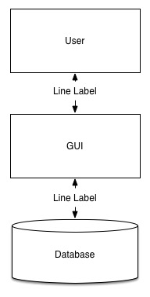

Based on the data processing step, we break down our system into the following subsystems: User Input, Graphical User Interface (GUI), and The underlying database. These subsystems are necessary to perform the data processing function that converts the input data into output data. The subsystem diagram in Figure 2 shows the relationship among these subsystems.

Figure 2: Subsystem diagram:
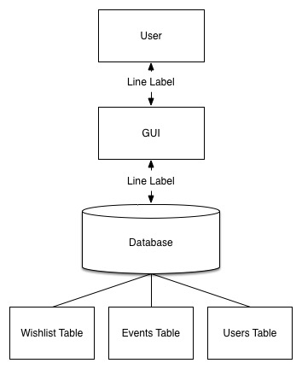
The database must store each instance of the objects within our project requirement. The objects are wish list, events, and users. Moreover, over each element in the table must point to the related elements in different database with foreign keys. Each item in the database must have unique key to identify it.

Figure 3: GUI Subsystem diagram:
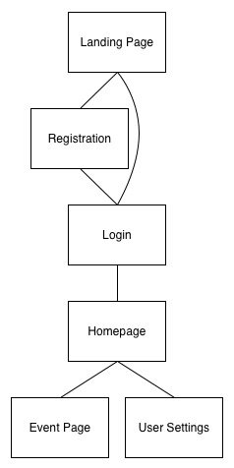

The GUI subsytem has 7 modules the landing module that displays the next logic states. The user can either be in the database or we must create a instance of the user. Once the user is in the databse, we must authenticate the user using thier key and hashable password. After authentication he can then display the applications homepage and present the two modules for interaction. The two logicical interaction modules would be the user settings and the event page. The user setting page will allow the users to update setting and user information. The events page will display events and allow the user to create new events.
Figure 4: Database Subsystem diagram 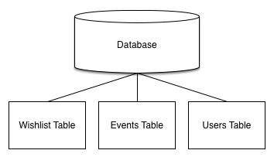

Following are the descriptions of the subsystems:

- Input subsystem: this subsystem receives the following input data from the user:
-The input subsystem allows the user to enter personal data to create an event using a combination of text boxes, drop down menus and buttons. This information is stored in the database tables under Users, Events or Wish lists while the input for changing settings such as fonts, colors results in automatic changes to the display.
- The Database subsystem contains tables labeled Users, Events and Wish lists. These Databases store related information and this subsystem is also responsible for enforcing constraints such as preventing name duplication and automatic system deletion of events.
- The GUI Output system displays the current date and time and lists the closest three events that are due. It also displays buttons to add an event, change settings or sort events by category.

The following table lists the subsystems that implement the requirements:
Requirement # | Subsystems
1 | Database session manager/class
2 | Database User Table
3 | Database to Input GUI socket manager
4 | Database Event Table
5 | Database Wish list Table
6 | Input GUI
7 | Output GUI (Events)
8 | Output GUI (User)
9 | Input GUI (Login)
10 | Input GUI (Events)
11 | Input GUI (User Info)
12 | Input GUI (Wish list Info)
13 | Input GUI (Event Settings)
14 | Input GUI
15 | Input GUI
16 | Input GUI
17 | Input GUI
18 | Input GUI to Database method
19 | Database to Input GUI methods
20 | Database

Possible enhancements:

Some possible enhancements to the application include:
- Allowing a user to keep the information private by requiring an account creation with password.
- Ability to access the application over different platforms
- Visual display of a list containing all reminders for a person (based on filter)
- Syncing birthdays from Facebook to load into application.
- Ability to notify user and send auto personalized E-Cards via the application the day of the event for that person.
-The system can be built to be dynamic and listen for updates and actions within the database and cache.
-The system can be deployed via a web server. Moreover, we deploy MemCacheD servers to cache data that is pertinent to specific area.
-We can make the database a graph based model instead of a rational database. Thus, being able to monitor vectors and edges, versus foreign keys within the instances row in a table.

Possible risks and risk mitigation:

Risk 1: Password cracking due to brute force attacks and session hijacking
Mitigation: Password Encryption; Making passwords not visible when typing in for user.

Risk 2: Interception of transmitted data; including personal data such as birthdays and anniversary dates.
Mitigation: Encrypted data during transmission and storage.
Risk 3: The user can input data that can cause the system to crash because the data is not within the constraints of the fields uses to store the data
Mitigation: Using fields that can dynamically change size wise, or constraining the input from the user with error handling

Risk 4: The server storing the data can possible time out, so we must set a window for time outs and retry to execute the corresponding command.
Mitigation: Dependent on final database decisions, timeouts can be handled by a wait message for the user and a continual retry.

